Information for Our NDIS Participant’s
Carers
2024
CONTENTS
Who are we? 2
About Us 3
Our Values 3
Client Centred 3
Innovation 3
Learning and Growth 4
Ethical Behaviour 4
Diversity 4
Safety 4
Fiscal Accountability 4
Teamwork and Collaboration 4
Services provided by Optimise Health and Wellness 5
Support Coordination 5
Support Work 5
Group Programs 6
Nursing 6
Occupational Therapy 7
Mental Health 7
How to access services and who to contact 8
Cancelling a service 8
Changing or adding a Service 9
Terminating your Service Agreement 10
Rostering 10
Requesting Equipment 10
Confidentiality 11
Feedback/Complaints 12
Emergency Action Plan 12
Key Personnel (Points of contact) 13
Reception 13
Practice Manager 13
Clinicians 13

Who are we?
A Message from Optimise Health and Wellness founder and director, Kara Christopher
Welcome to Optimise Health and Wellness where we aim to create opportunity, promote independence and progression in a safe and non-discriminative environment.
Here at Optimise Health and Wellness our direction is led by your choice, needs and goals by providing goal-oriented services to those who seek support.
This handbook is a guide created for you so you can learn more about Optimise Health and Wellness that are available to you and how we can help you. Find out all you need to know about us, what we do, the services we offer and most importantly how we will work with you to meet your needs to the highest standards.
At Optimise Health and Wellness we pride ourselves on the personal, client focused and high-quality service that we provide. We follow the NDIS guidelines to maintain excellent results for both you, your family and us.
We believe it is not only important to tailor our services to meet your needs but to provide the highest quality services so you can truly get the most out of your NDIS Plan. Following this, you will always know what to expect from us.
At Optimise Health and Wellness, we would like to make a difference for the disabled making their lives easier, happier and to produce better outcomes.
We will endeavor to give you a personal and individualized experience and you will be treated fairly throughout your time with us, choosing to do the things that are important to you. With your help we can also continuously work to improve our services to meet your needs and goals
Welcome to the Optimise Health and Wellness family!

About Us
Optimise Health and Wellness launched in January 2018 from our Ingham location. We opened as a multidisciplinary service providing occupational therapy, allied health assistance and mental health intervention. Today our service offerings have expanded, so too have our staff numbers. Services now include Occupational therapy, Dietetics, Exercise Physiology, Allied Health Assistants, Personal Trainer, Mental Health Clinicians, Support Coordinators (complex case managers), plan management (NDIS financial management of plans) and support workers offering both in home support and community access.

Our Values
At Optimise Health and Wellness, we live our values so that we can help our Participants achieve their goals and to ensure they feel connected and cared for.

Client Centred
Optimise takes a client centred approach. This means we like to look at things from the client’s point of view to ensure that when we interact or make decisions the Participant and their carers can feel that we are in their corner. It also means that we strive to do as much as we can to help clients and their carers by focussing on finding solutions to reaching goals rather than the barriers.

Innovation
In alignment with being client centred, we like to find new and creative ways of helping our Participants and support their caregiveres. We focus on problem-solving and finding creative solutions. We also don’t do something new and different for the sake of it, we do it because it is the best choice for our Participants.

Learning and Growth
Our staff at Optimise are always learning and growing to help our Participants. Whether it be completing certificates/degrees to gain new skills or working together to share knowledge. More importantly, we like to walk the path with our Participants and their caregivers to see them learn, grow, and achieve.

Ethical Behaviour
At Optimise, we will always act with integrity and act in accordance with the guidelines we work under. More importantly, we will behave ethically so that our Participants and their caregivers can trust us and know that we respect them.

Diversity
At Optimise our staff and our Participants come from a wide range of backgrounds. It is the uniqueness of our people that we love the most. We like to create an environment where people are able to be their true authentic self.

Safety
We care about our staff, Participants, and carers, and so their physical, mental, and emotional wellbeing is important to us. We take a considered approach to what we do to control any risk. We also try and be proactive, by ensuring our people feel connected to increase the resilience of their mental wellbeing.

Fiscal Accountability
Trust is an important factor, including when it comes to money. We strive for transparency and accuracy in this area so that the stress of managing budgets is reduced. We are open to queries to set your minds at ease, so we can focus on achieving goals of the person in your care.

Teamwork and Collaboration
We believe in a holistic approach. We work with our Participants and their caregivers to achieve their goals. We also work within the broader Optimise team and develop partnerships with other organisations so that our Participants have access to the services they need to achieve their goals.

Services provided by Optimise Health and Wellness

Support Coordination
The Participants plan may include funding to engage a Support Coordinator. Support coordination helps you to make the best use of the supports in the Participant’s plan. Support coordination is a capacity building support which helps you to:
- Understand and use you NDIS plan to pursue the goals of the person in your care
- Connect you with NDIS providers, community, mainstream and other government services
- Build your confidence and skills to use and coordinate supports.
This support will assist you to build the skills you need to understand and use your Participant’s plan. A support coordinator will work with you to ensure a mix of supports are used to increase your capacity to help the person in your care maintain relationships, manage service delivery tasks, live more independently, and be included in their community.

Support Work
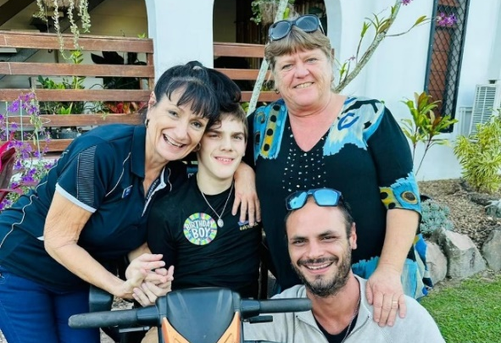
Support workers are compassionate professionals who assist individuals with various needs, including physical disabilities, mental health challenges, or learning difficulties. They provide both practical and emotional support, helping with daily tasks like personal care, cooking, and medication, while also promoting independence and social connection. It's a rewarding role focused on empowering individuals to reach their full potential and live thriving lives within their communities.

Group Programs
Optimise Health and Wellness offer a range of group programs. These programs are designed so that people with a diverse range of needs can develop skills and engage socially within the community. Our programs help build capacity to live meaningful lives and build connections. Our group programmes include:
- Kids cooking club
- Seated Yoga
- Group excursions (including tenpin bowling, Ninja Parc, environmental trips etc.)
- Exercise groups at our own community gym
With many more programs being offered throughout the year.

Nursing
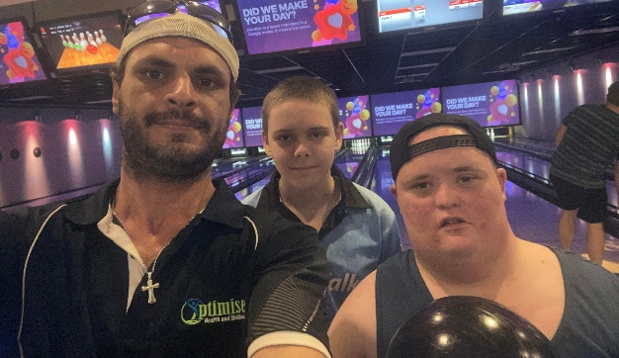
Nurses are your partners in health, working alongside various professionals to support you and the Participant throughout their journey. Nurses provide direct care, managing your medications, monitoring your health, and offering comfort and compassion. From preventive care to recovery, they advocate for the Participant’s needs and empower you to make informed decisions about their well-being. Think of them as your guides, navigators, and cheerleaders, dedicated to helping the person in your care flourish in every stage of life.

Occupational Therapy
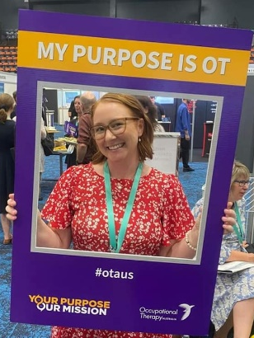
Occupational therapy helps people of all ages regain or improve skills for daily living and meaningful activities after injury, illness, or disability.
Think of them as the Participant’s personal coach for everyday life. Using exercises, adaptive equipment, and tailored strategies, occupational therapists empower the Participant to do the things that matter most, whether it's taking care of themself, returning to work, or pursuing hobbies. It's all about regaining independence and participating in their life to the fullest.

Mental Health
Mental health is our emotional, psychological, and social well-being. It shapes how we think, feel, and act, impacting our daily lives and relationships. Just like physical health, it needs nurturing. Good mental health allows us to cope with stress, build strong connections, and live fulfilling lives. If you or the person in your care is struggling, reaching out for support is a sign of strength, not weakness. At Optimise our compassionate Mental Health Clinician is available to offer support. We can also connect you with other helpful people and services.
Key Processes

How to access services and who to contact
There are many elements to the Participant’s plan. We are here to assist and support you to better understand their plan and get the most out of their funding. We will offer you an initial establishment meeting with our Intake Officer to help you understand what the Participant has been funded for, and how you can use it and other supports to help get you started. You can contact us by phone or email at any time to ask further questions. We are here to help you make informed decisions.
If you have any questions regarding services, would like to make any changes, or need to contact us after hours, please call reception on (07) 4423 7662 and they will put you through to the relevant person.

Cancelling a service
If you need to cancel a service call reception to do so. Please do this as soon as possible to avoid a short notice cancellation.
The NDIS considers a cancellation “short notice” if the Participant cancels the service with less than 7 clear days' notice before the support is due to take place.
To avoid paying a cancellation fee, a Participant and their carer should do the following:
- Show up for the scheduled support at a reasonable time
- If the provider is travelling, the Participant should be at the agreed-upon destination within a reasonable time
- If a cancellation is required, the Participant should give the appropriate amount of notice outlined in the NDIS Pricing Arrangements and Price Limits
If a Participant doesn’t meet the criteria above, the provider may claim for the cost of short notice cancellation. In these situations, a provider may claim 100% of the agreed-upon fee.

Optimise Health and Wellness has a duty of care to our Participants. Although there is no strict limit for how many short notice cancellations can be claimed from the Participant’s funding, Optimise Health and Wellness has an obligation to protect our client’s welfare.
Optimise Health and Wellness will seek to know why cancellations are occurring, particularly in circumstances where cancellations are happening frequently.
Claims for cancellations are routinely monitored by the NDIA. Optimise Health and Wellness participants with an unusually large number of cancellations may be contacted.

Changing or adding a Service
Changing or adding a service may require amending the Participant’s service agreement. If you require a change to an existing service or wish to add a new service, then call reception who will then direct your call to the intake officer. The intake officer will work with you on amending your service agreement and booking/changing relevant services.
If the requested changes are within the scope of the current service agreement, then reception will organise the relevant changes or direct you to the relevant staff member.

Terminating your Service Agreement
You may want to end the service agreement. This could be because:
- The needs of the person in your care have changed
- their disability has improved or declined
- you want to try a different support/treatment/therapy for the person in your care
- the Participant has reached their goal
- you do not feel the provider is a good fit for the person in your care
Before you end the service agreement, you can talk with Optimise Health and Wellness. You could ask if we can change our supports and services to meet the needs and preferences of the person in your care. You might be able to keep the current service agreement but change the supports delivered by Optimise Health and Wellness.
You have the right to terminate services with Optimise Health and Wellness at any time. You must give us 1 months’ notice if you wish to leave our services. You will be offered an exit interview, where we can discuss the reason for leaving and obtain feedback about how we can improve our service.

Rostering
Staff rostering is the process of creating and assigning support workers their shifts to work with Participants. Optimise Health and Wellness will assign more than one support worker to work with the Participant. Whilst we encourage the Participant to choose the support worker they would like to have, sometimes this is not possible.
Safeguards are important to protect your right to be safe and receive quality services from Optimise Health and Wellness staff. Here at Optimise Health and Wellness we provide more than 1 support worker who will work with the Participant on a rotational roster to provide and deliver quality services.

Requesting Equipment
Assistive Technology falls into the Capital Supports Budget which can include higher-cost pieces of assistive technology, home or vehicle modifications and funding for one-off purchases you may need, including Specialist Disability Accommodation.
It is important to remember that funds within the Capital Supports budget can only be used for their specific purpose and are not flexible to pay for anything else.
If you require Assistive Technology equipment or Home Modifications and it is not in your current plan, your Occupational Therapist will need to show the evidence in writing to NDIS. It needs to confirm the device is the most appropriate solution for your disability support needs. After this is provided to NDIS with the evidence, they will include funding for the item in the Participant’s plan if it meets all the NDIS funding criteria.

Confidentiality
When you deal with us, we need to collect certain information about the Participant. This is so we know who they are and how we can help them. If they’re an applicant or a participant, we also need to know how their disability affects them. We use this information to make sure they get the supports they need.
We take yours and their privacy seriously. When we talk about privacy, we mean that we make sure we protect personal information. We’re committed to keeping this information safe. This information includes, things:
- you or the Participant have told us.
- others have told us about the Participant (for example, other medical professionals)
- we have recorded about the Participant and their current plan.
The information we hold about you or someone else, is called personal information and is protected. We keep a record of our conversations with you and the Participant, and we keep copies of documents or papers you give us.
We store copies of documents or papers you give us on our secure computer systems.

Feedback/Complaints
Optimise Health and Wellness welcomes feedback, including complaints. We believe people have a right to speak up as it helps us to see what works, what doesn’t and where we can make improvements in our products and services.
To make a complaint or provide feedback, please scan the QR Code or go to www.optimisehealthandwellness.com.au. You can also speak to the practice manager or your assigned clinicians are the best people to assist you. If you want information about our services or are unsure about something, you can send an email to hello@optimisehealthandwellness.com.au or call us on 1800 955 682. Our support staff can help you with making this contact but they are not responsible for passing on or processing complaints.
We will resolve your complaint as quickly as possible. Our Complaints Procedure requires that we:
- take immediate action where there appears to be a high risk of harm, neglect, or abuse.
- aim to acknowledge complaints within the next business day from receipt.
- call you within two business days of acknowledgement.
- aim to resolve complaints within 21 business days of receipt.
When we contact you to talk about your complaint, we may ask you to provide more information to help us understand the nature of your complaint. If a staff member is the subject of a complaint, we will contact the staff member, provide them with details and ask for their comments and relevant information. We will let the complainant know what they say in response to the complaint.
All complaints and feedback will be dealt with by us in a professional and confidential manner; however, if you are unsatisfied with our feedback and complaints resolution process, or you do not feel comfortable contacting us directly, you have the right to contact the NDIS commission. You can do this through filling out their on-line complaints form or phoning them on 1800 035 544 (free call from landlines) or TTY 133 677. They have a Translating and Interpreting Service available on 131 450 or you can contact the National Relay Service and ask for 1800 035 544.

Emergency Action Plan
In the case of an emergency (e.g. cyclone, bushfire, flood etc.) Optimise Health and Wellness staff will communicate with its participants and their carers to ensure that adequate care can be provided. Optimise will ensure that adequate support staff are located in affected areas. If this is not possible, Optimise will work with the participant to relocate them so that they are able to receive the care they need during the course of the emergency situation. Optimise will communicate with key personnel during the emergency situation to ensure the safety of its participants, and support in relocation or evacuation as necessary. If there is warning of a pending emergency situation, Optimise will also work with the participants and their carers to ensure they have adequate supplies.
Optimise will communicate via its Facebook page, email, and phone. If you have concerns in these periods please contact us on (07) 4423 7662. If you or the Participant are in a life-threatening situation, please call 000.

Key Personnel (Points of contact)
Reception – These people are the face of Optimise Health and Wellness, and are who you call. They will take your call and address any questions or concerns or they will direct you to the relevant staff.
Practice Manager – Our Practice Manager will address any concerns or queries you have regarding our Support Services and Support Staff
Clinicians - These are the people who provide relevant high quality therapies. They are also who you talk to with queries specific to treatment, or requesting equipment
